Contents
1.1 Thonny (For Wifi) 1
1.2 Mosquitto (For MQTT) 3
1.3 Heartbeat 1-second interval 5
1.4 5-minute MQTT telemetry delivery target (at least 95%) 7
1.5 Automatic MQTT reconnection 8
1.6 Other commands test 8

1.1 Thonny (For Wifi)
1) Install thonny (https://thonny.org) and open thonny
2) Download the py file that I put then change the SSID and PW to ur own wifi credentials (at line 4 and 5)
3) Bottom right the local python 3 there u click then click "Install MicroPython"
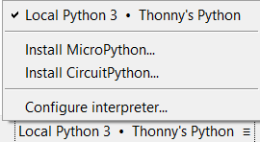
4) After installing, u shld see got the rasp pi pico board CDC @COMx (x is ur com number. Eg COM4). Click on that one
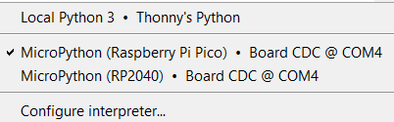
(if didn’t see, can click configure interpreter, then double check that u selected the micopython + the COMx)
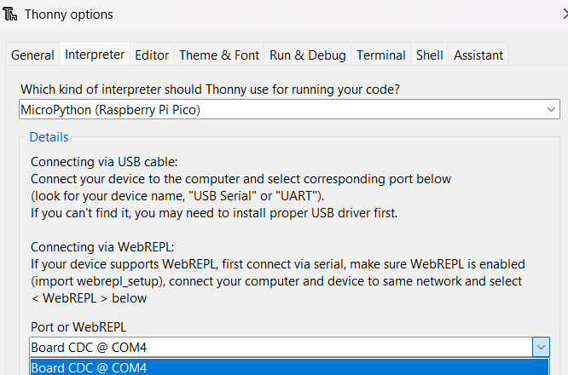

5) Save the code (click file>save as) into both ur computer (as backup) and to raspberry pi pico (so that every time u boot pico, it will auto run)
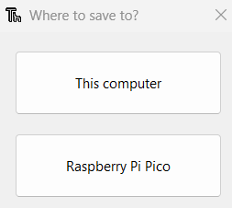
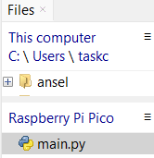 can see that the main python file is saved at the pico there. (if cannot see this panel at the left side, u need to click view>files on top)
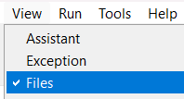

6) click run current script on top then u shld see the wifi connected msg alongside u IP address. (Remember to use 2.4 GHz Wifi. CANNOT use 5 GHz. If 5g, will not connect)
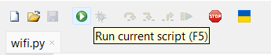
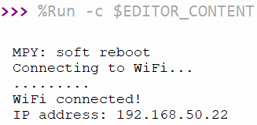

1.2 Mosquitto (For MQTT)
1) Install Mosquitto (https://mosquitto.org/download/)
2) Go to Thonny and click Tools>Manage Packages
3) Search for umqtt.simple and install the package
Shld look like this after installed
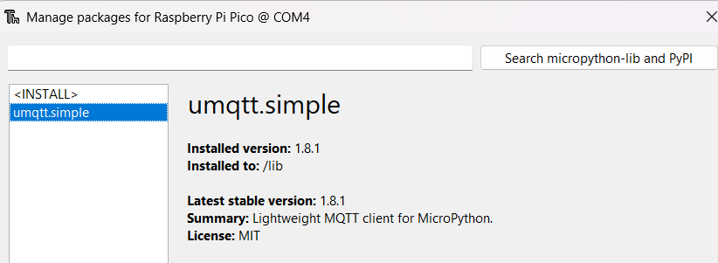
4) If u wanna test to see if mqtt lib is installed correctly, u go the shell there and type
from umqtt.simple import MQTTClient
if got no error/output come out means correct
5) Find ur computer’s ip add (command prompt then ipconfig. IP add eg that ill use for ltr. Need to rmb to change to urs later: 192.168.50.169)
6) Download the pico_mqtt.conf file that I put then save it at desktop (or wherever. Btw u need to rmb the file directory/path for this coz ltr need)
7) Open command prompt (as admin) then type this (rmb to change ur file path)
"C:\Program Files\Mosquitto\mosquitto.exe" -c "C:\Users\ur_username\OneDrive\Desktop\pico_mqtt.conf" -v
U change the C:\Users\ur_username\OneDrive\Desktop\ to ur file path keep the pico_mqtt.conf -v
Btw from here onwards, DO NOT close any command prompt coz this first one is the mqtt broker. Then the other command prompts are used to listen for mqtt msgs.
Shld be able to see the version number and the listen port as the output:
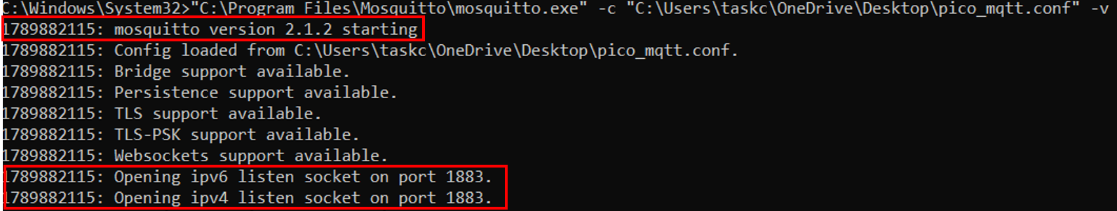
8) Open another command prompt (as admin) then type these 2 new lines (1 by 1) for listening
cd "C:\Program Files\Mosquitto"
mosquitto_sub -h 127.0.0.1 -t car/test -v
9) Open another command prompt (as admin) then type these 2 lines (1 by 1) for testing
cd "C:\Program Files\Mosquitto"
mosquitto_pub -h 127.0.0.1 -t car/test -m "Hello from PC"

the output from the step 8’s cmd shld display this (have means working):
10) Go to thonny and run these 4 commands at the shell (change the ip add to u ip add)
from umqtt.simple import MQTTClient
client = MQTTClient("pico_test", "192.168.50.169", port=1883)
client.connect()
print("MQTT connected!")

if it’s successful, it will print the MQTT connected
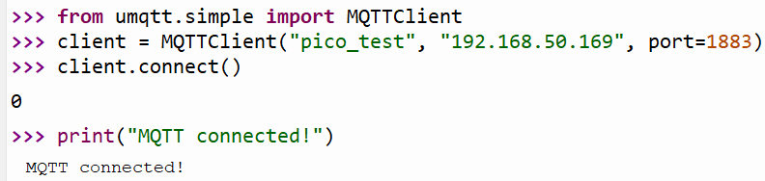
Then from the main cmd window, it should show this (means pico connected to mqtt)
11) At the thonny shell, type this:
client.publish(b"car/test", b"Hello from Pico W!")
Then go to the command prompts and see that it shld have the hello from Pico W (if don’t have just press enter from hello from pc there)
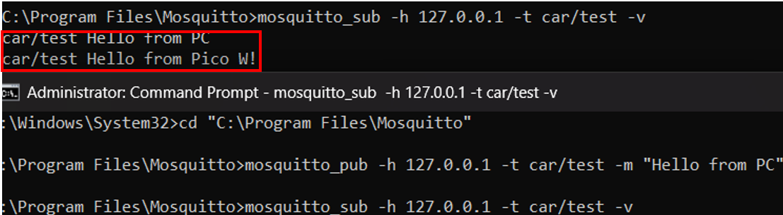

1.3 Heartbeat 1-second interval
1) On 1st command prompt type this
"C:\Program Files\Mosquitto\mosquitto.exe" -c "C:\Users\ur_username\OneDrive\Desktop\pico_mqtt.conf” -v
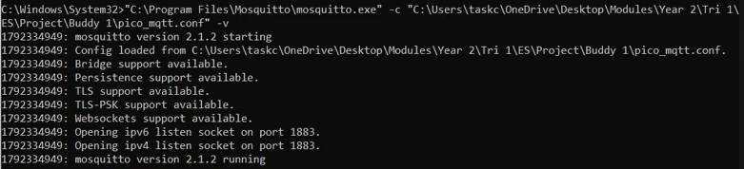
2) On another command prompt type this
"C:\Program Files\Mosquitto\mosquitto_sub.exe" -h 127.0.0.1 -t car/telemetry -v
3) Go to thonny and run these 4 commands at the shell (change the ip add to u ip add)
from umqtt.simple import MQTTClient
client = MQTTClient("pico_test", "192.168.50.169", port=1883)
client.connect()
print("MQTT connected!")

if it’s successful, it will print the MQTT connected (if client.connect doesn’t print anything, just go back to the 1st command prompt and hit enter)
Then from the main cmd window, it should show this (means pico connected to mqtt)
4) At the thonny shell, type this:
client.publish(b”car/telemetry”, b”Manual MQTT test”)
5) Go back to subscriber window and u shld see the output
6) Go back to Thonny and use the new main.py and save it to RSP2040 overwrite it. Click “Run” and u shld see the following output on Thonny, cmd 1 and cmd 2 respectively
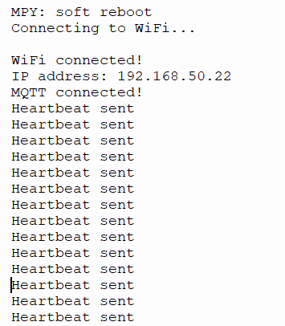
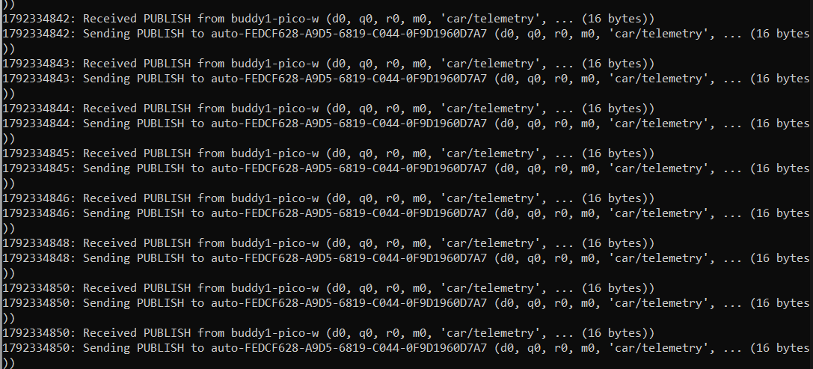
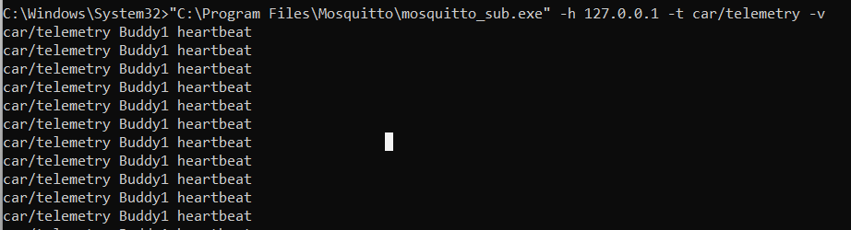

1.4 5-minute MQTT telemetry delivery target (at least 95%)
For this test, u can use the code from “main test.py” and overwrite main.py (save to pico). The output shld be 300 heartbeat in 5 mins with full uptime (or minimum 95% uptime).
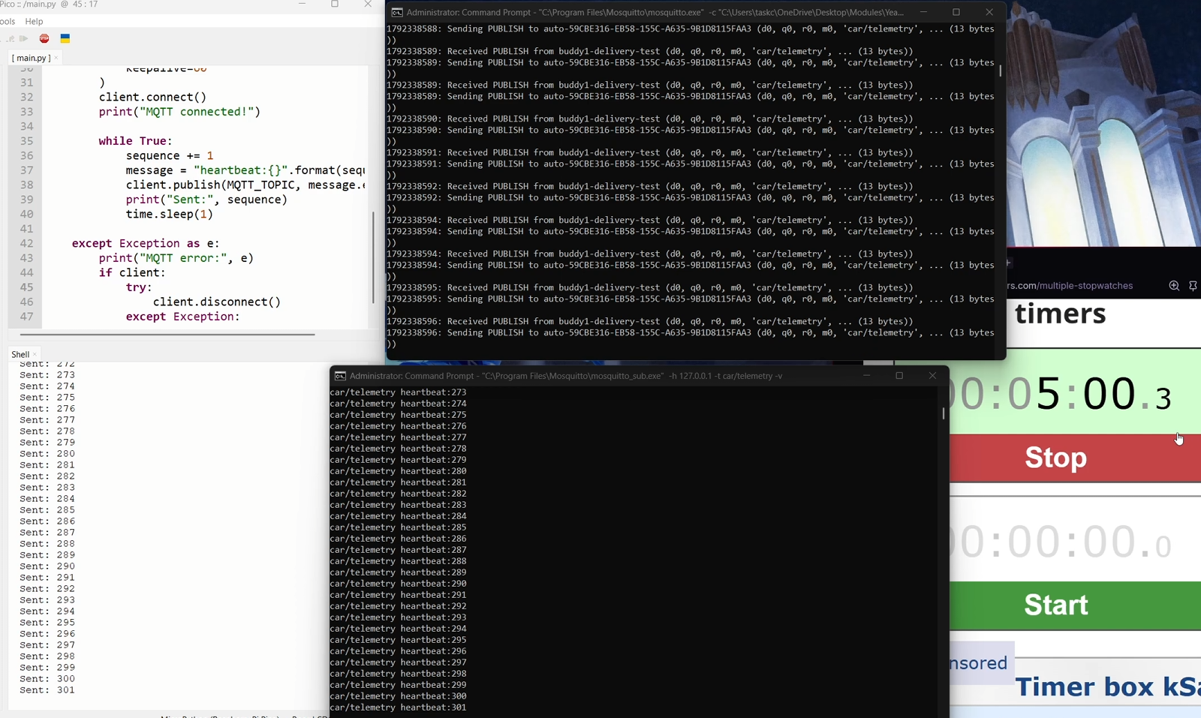

1.5 Automatic MQTT reconnection
1) Same as 1.3 Step 6, u run the main.py code first
2) Disconnect the MQTT broker by pressing ctrl+c on the 1st command prompt (the one where it is showing the mosquito version xxx and received PUBLUSH from buddy1)
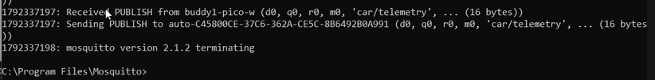
^ might be a bit buggy when quitting can try making sure that u got click that and maybe spam ctrl+c
3) Once it stopped, u can see that thonny will show that MQTT connection has reset and aborted
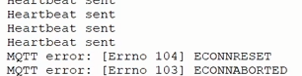
4) Open new command prompt and type that command again then thonny shld say that the MQTT has reconnected/MQTT connected
The command to put in cmd:
"C:\Program Files\Mosquitto\mosquitto.exe" -c "C:\Users\ur_username\OneDrive\Desktop\pico_mqtt.conf” -v
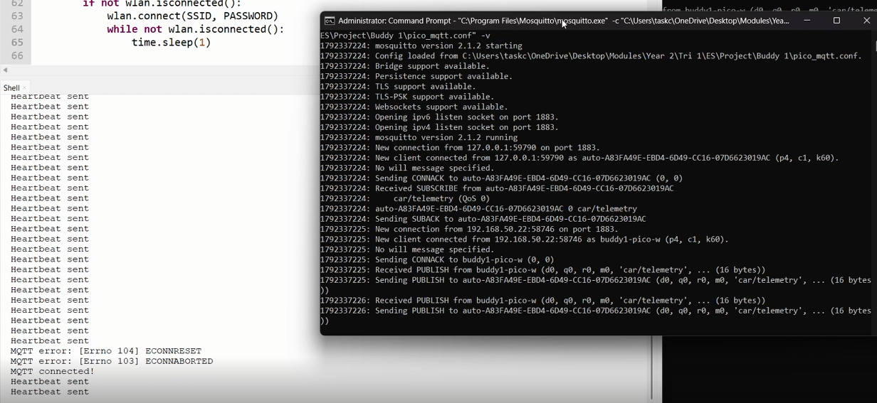

1.6 Other commands test
1) Copy the code from “main test no2.py” and save and overwrite main.py with it.
2) On 1st command prompt type this
"C:\Program Files\Mosquitto\mosquitto.exe" -c "C:\Users\ur_username\OneDrive\Desktop\pico_mqtt.conf” -v
3) On 2nd command prompt type this
"C:\Program Files\Mosquitto\mosquitto_sub.exe" -h 127.0.0.1 -t car/telemetry -v
4) On 3rd command prompt type this
“C:\Program Files\Mosquitto\mosquitto_sub.exe" -h 127.0.0.1 -t car/safety -v
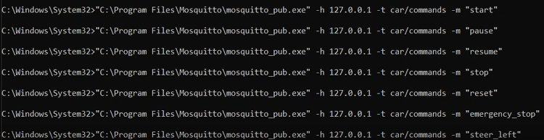
5) On 4th command prompt type the following 1 by 1. U will see the results in thonny
